2015 Kahshe and Bass Lake Steward Report
Executive Summary
In accordance with the goals and objectives for the Kahshe Lake Steward, a comprehensive review and analysis of all historical environmental monitoring on Kahshe and Bass Lakes has now been completed and presented within Lake Steward Reports for 2012, 2013 and 2014. These documents are posted on the KLRA web-site (http://www.kahshelake.ca/ne/ls). This report captures the findings from sampling and analysis of both Kahshe and Bass Lakes in 2015. The sampling programs include those of two agencies: The District Municipality of Muskoka (DMM) and the Ontario Ministry of Environment and Climate Change (MOECC). In the latter, the Lake Stewards of Ontario carry out the sampling and measurement and the MOECC analyzes the samples and coordinates the data reporting.
In an effort to simplify the findings for Kahshe and Bass Lakes, this report has been structured to address the following issues/areas of potential concern for both lakes:
- Total Phosphorus and Water Clarity
- Calcium Depletion
- Lake Acidification
- Dissolved Oxygen and Water Temperature
- Metals and Other Chemicals
- Benthic Health
The map below shows the locations of all sampling site for both DMM and MOECC sampling programs, while the summary table that follows provides brief information on each of the six issues.
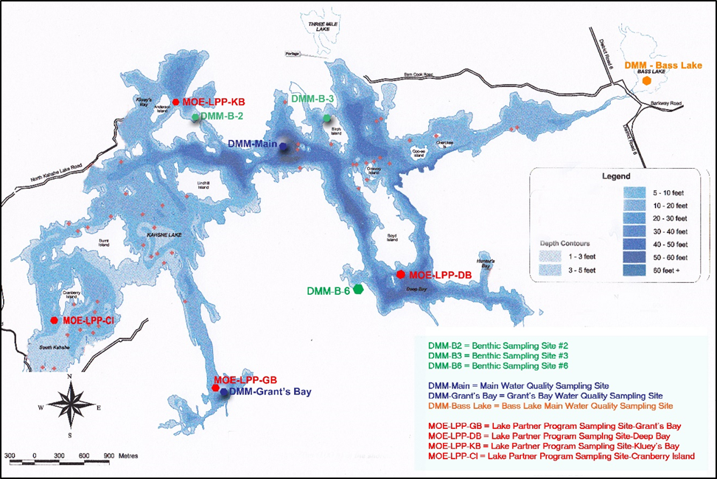
Summary of 2015 Findings for Kahshe and Bass Lakes
Measure | Why It’s Important | Versus Benchmark* | Comments
Total Phosphorus (P) and Water Clarity | - An indicator of water quality degradation and potential for algal blooms.  - Linked to planning & development restrictions.  - Total P benchmark set to preserve water quality via a background approach.  - Natural tea colour of water complicates clarity findings. |  | - Background-based model review now completed and P benchmarks to be revised.  - New DMM approach does not change good water quality status for Kahshe L.  - However, Bass Lake now flagged for further study because of elevated phosphorus.
Calcium Depletion | - Calcium is naturally occurring in soils and rocks and is essential component of aquatic food chain.  - There was enhanced leaching from soil to lakes due to acid rain impacts in 1970s & 80s.  - Many Muskoka lakes now at lower end of aquatic threshold. |  | - Not a shoreline development issue.  - Calcium in Kahshe and Bass L. is currently above benchmark (good), but need to keep monitoring and watch for signs of decline.
Lake Acidity (pH) | - In mid to late 1900s, sulphur and other acid gasses from the Sudbury basin plus transboundary air flows from the U.S. acidified many lakes.  - Most lakes in Muskoka have recovered following emission controls. |  | - The Ontario objective is to keep pH between 6.5 and 8.5.  - Kahshe and Bass Lakes are 10-20 times above the lower pH limit, so there is no concern for impacts on aquatic species.  - However, both lakes have a low buffering capacity, so we need to keep monitoring.
Dissolved Oxygen (DO)  And Water Temperature | - Oxygen is essential for all aquatic organisms.  - It enters surface water from the air and is transferred down to lower depth waters via spring and fall water turnover.  - Levels in the bottom waters deplete during the summer and can become anoxic and impact aquatic survival and also release P from sediments. |  | - The PWQO for DO in warm water lakes is 5 mg/L.  - The DO levels in mid and lower layers of water in both lakes often drops below the desirable benchmark.  - However, neither Kahshe nor Bass L. is considered anoxic and the lower DO levels are tolerated or avoided by aquatic organisms.  - The report also charts the 30 year trends in water temperature which show no obvious up or down trend.
All Other Chemicals | - DMM samples and analyzes Kahshe and Bass L. for over 30 different metals, nutrients and other chemicals.  - They briefly discuss about a dozen of them.  - This report analyzes them relative to chronic toxicity benchmarks and charts them all since monitoring began in early 2000s. |  | - All 30 have been compared to chronic toxicity benchmarks from Ontario, Canada and the U.S. EPA.  - Most are well below aquatic benchmarks in both Kahshe and Bass L.  - A few benchmark exceedances are likely due to analytical problems or benchmarks that are not well supported.
Benthic Health | - Counting of aquatic invertebrates (worms, mollusks, insects, crustaceans and mites) has been carried out by the DMM and KLRA on Kahshe L. since 2003.  - This gives us an early warning of possible environmental impacts. |  | - Benthic index values from all 3 sampling locations on Kahshe L. are similar to the Muskoka reference (natural) levels.  - No problems in the population, growth or survival of aquatic invertebrate which can be related to contamination or habitat disturbance.
DMM means District Municipality of Muskoka
*
- Levels are within accepted benchmarks for water quality

- No obvious upward or downward trend has been detected since monitoring began

In conclusion, based on the foregoing summary of the environmental monitoring of Kahshe and Bass Lakes no major issues in terms of environmental quality have been detected. The possible exception is total phosphorus in Bass Lake, which has been flagged by DMM for more intensive study as a result of the review of their background-based water quality model. The additional study will be designed to determine the cause of the elevated total phosphorus in Bass Lake and to determine if any further development restrictions are warranted.
Although there are no major environmental issues, we need to continue with our sampling efforts and practice overall lake stewardship to delay the onset of nutrient enrichment and its impact on lake health. How can we make a difference?
Each of us can do our part to maintain the quality of the water by:
- managing our septic systems properly and having tanks pumped out regularly;
- avoiding the use of products containing phosphorus (detergents and cleaners);
- disposing of toxic wastes (batteries, paint, oil, old gas, pressure-treated lumber and other construction waste) at approved land fill sites;
- minimizing near-shore removal or management of vegetation and ensuring that any shoreline disturbance is conducted in compliance with permitted uses;
- avoiding the use of any chemical fertilizers or pesticides in areas close to the shore; and,
- taking precautions to minimize the potential for introducing both terrestrial and aquatic invasive species.

